Phase-5 Practice Project: Assisted Practice -

4.Deploy your Application:

wget https://amazon-eks.s3-us-west-2.amazonaws.com/1.10.3/2018-07-

26/bin/linux/amd64/kubectl chmod +x kubectl

./kubectl

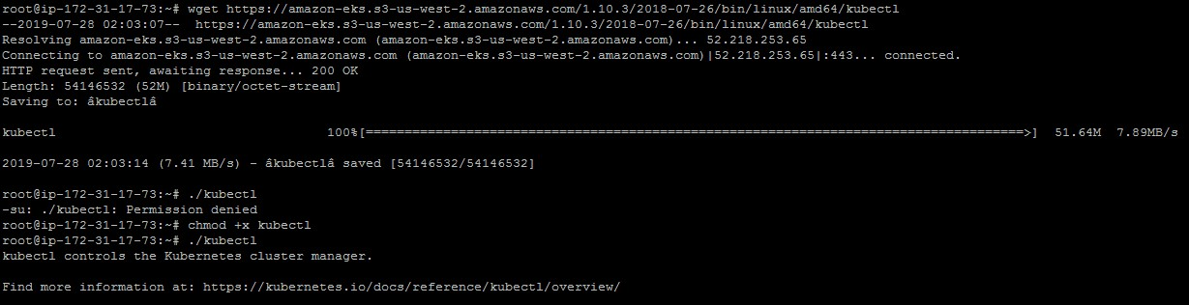

mkdir bin cp ./kubectl $HOME/bin/kubectl && export PATH=$HOME/bin:$PATH kubectl version

kubectl version --short --client

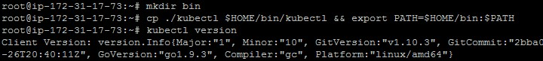

wget https://amazon-eks.s3-us-west-2.amazonaws.com/1.10.3/2018-07-

26/bin/linux/amd64/aws-iam-authenticator chmod +x ./aws-iam-authenticator

cp ./aws-iam-authenticator $HOME/bin/aws-iam-authenticator && export PATH=$HOME/bin:$PATH

aws-iam-authenticator help

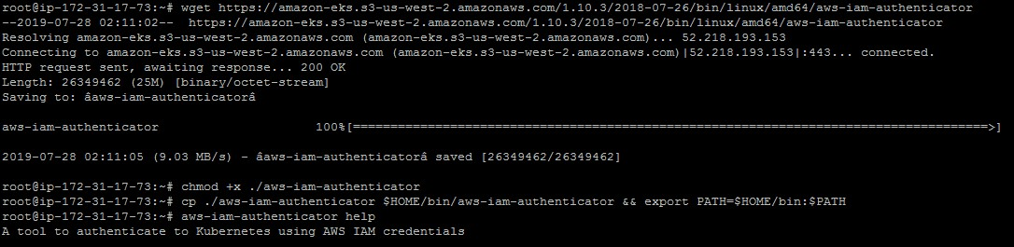

curl --silent --location

"https://github.com/weaveworks/eksctl/releases/download/latest_release/ eksctl_$(uname -s)_amd64.tar.gz" | tar xz -C /tmp mv /tmp/eksctl /usr/local/bin

eksctl version

